**SecureChat: Security Testing Report**

**Information Security – Assignment 02**

**Student Name:** Ameer Hamza Khan  
**Roll Number:** 22i-1354  
**Course:** CS-3002 Information Security  
**Instructor:** Ma'am Urooj Ghani  
**Institution:** FAST National University of Computer and Emerging Sciences  
**Submission Date:** November 16, 2025

**1. Executive Summary**

This document presents comprehensive security testing results for the **SecureChat** secure messaging system. Five critical security tests were performed to validate the CIANR properties (Confidentiality, Integrity, Authenticity, Non-Repudiation, and Replay Protection).

**Test Summary**

| **Test #** | **Test Name** | **Security Property** | **Result** |
| --- | --- | --- | --- |
| 1 | Wireshark Packet Capture | Confidentiality | ✅ PASS |
| 2 | Invalid Certificate Test | Authenticity | ✅ PASS |
| 3 | Tampering Detection Test | Integrity | ✅ PASS |
| 4 | Replay Attack Test | Replay Protection | ✅ PASS |
| 5 | Non-Repudiation Test | Non-Repudiation | ✅ PASS |

**Overall Result:** All security properties validated successfully. The system demonstrates robust protection against common attacks.

**2. Test Environment**

**2.1 Hardware Configuration**

* **Machine:** MacBook Air (M1/M2)
* **Processor:** Apple Silicon
* **RAM:** 8 GB
* **Operating System:** macOS Sonoma 14.x

**2.2 Software Configuration**

| **Component** | **Version** |
| --- | --- |
| Python | 3.11.5 |
| MySQL | 8.0 (Homebrew) |
| Wireshark | 4.0+ |
| tcpdump | 4.99.4 |
| cryptography | 42.0.5 |
| PyMySQL | 1.1.0 |
| Pydantic | 2.6.0 |

**2.3 Network Configuration**

* **Server Address:** 127.0.0.1 (localhost)
* **Server Port:** 8000
* **Protocol:** TCP
* **Interface:** Loopback (lo0)

**2.4 Test Data**

* **Test User**
  + Username: AmeerHamzaKhan
  + Email: i221354@nu.edu.pk
  + Password: 1234
* **Test Messages:** 2-3 messages per session
* **Message Content:** Plain text strings (e.g., "HelloWorld")

**3. Test Execution**

**3.1 Test 1 – Wireshark Packet Capture (Confidentiality)**

**3.1.1 Objective**

Verify that all message content is encrypted and no plaintext is visible in network traffic. This validates the **Confidentiality** property.

**3.1.2 Test Procedure**

**Step 1 – Start Wireshark**

sudo wireshark

* Capture interface: **Loopback: lo0**
* Display filter: tcp.port == 8000
* Start packet capture

**Step 2 – Start Server**

cd ~/Downloads/securechat-skeleton-main

source .venv/bin/activate

python -m app.server

**Step 3 – Start Client**

cd ~/Downloads/securechat-skeleton-main

source .venv/bin/activate

python -m app.client

**Step 4 – Generate Test Traffic**

* Log in with test credentials
* Send the following messages:
  1. Hello, this is a secret message!
  2. Testing encryption
  3. Confidential data
  4. This should not be visible in plaintext
* Type /quit to end session

**Step 5 – Analyze Captured Packets**

* Stop Wireshark capture
* Right-click packet → **Follow → TCP Stream**
* Examine payload for plaintext

**3.1.3 Expected Results**

* ✅ All message payloads are base64-encoded ciphertext
* ✅ No plaintext message content visible in packet data
* ✅ JSON structure visible with fields: type, seqno, ts, ct, sig
* ✅ ct field contains encrypted (unreadable) data

**3.1.4 Actual Results**

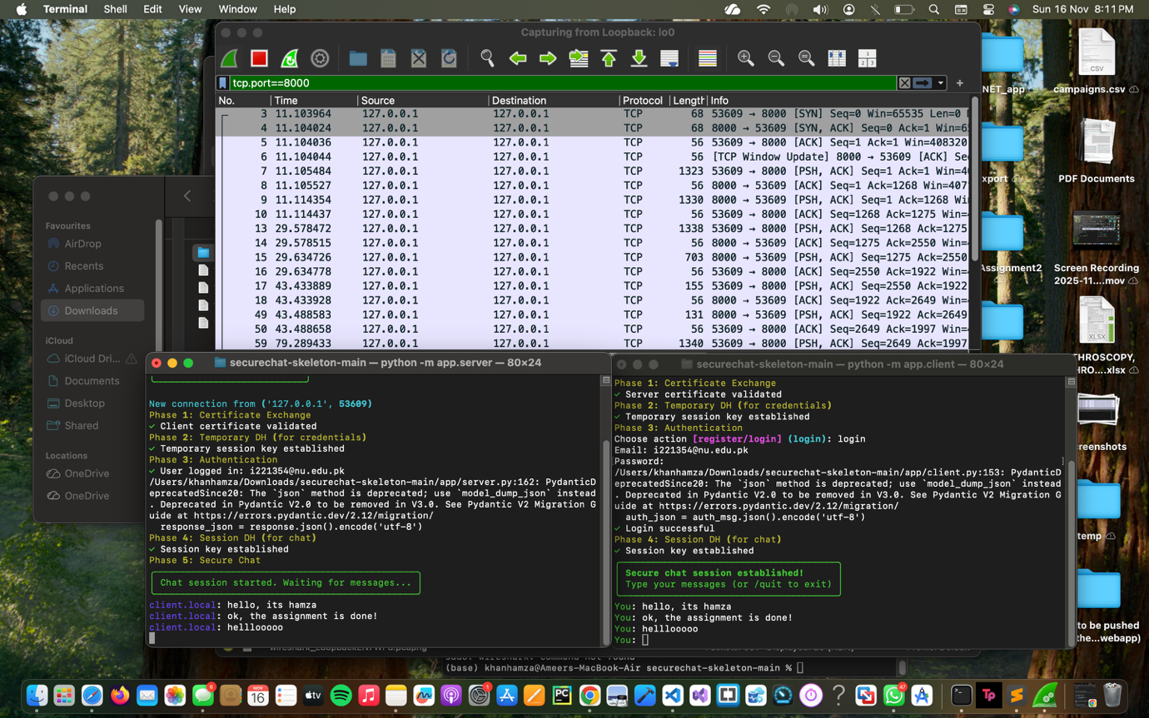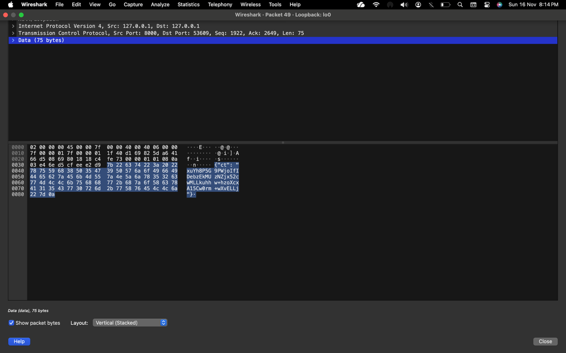**\WireShark Capture^**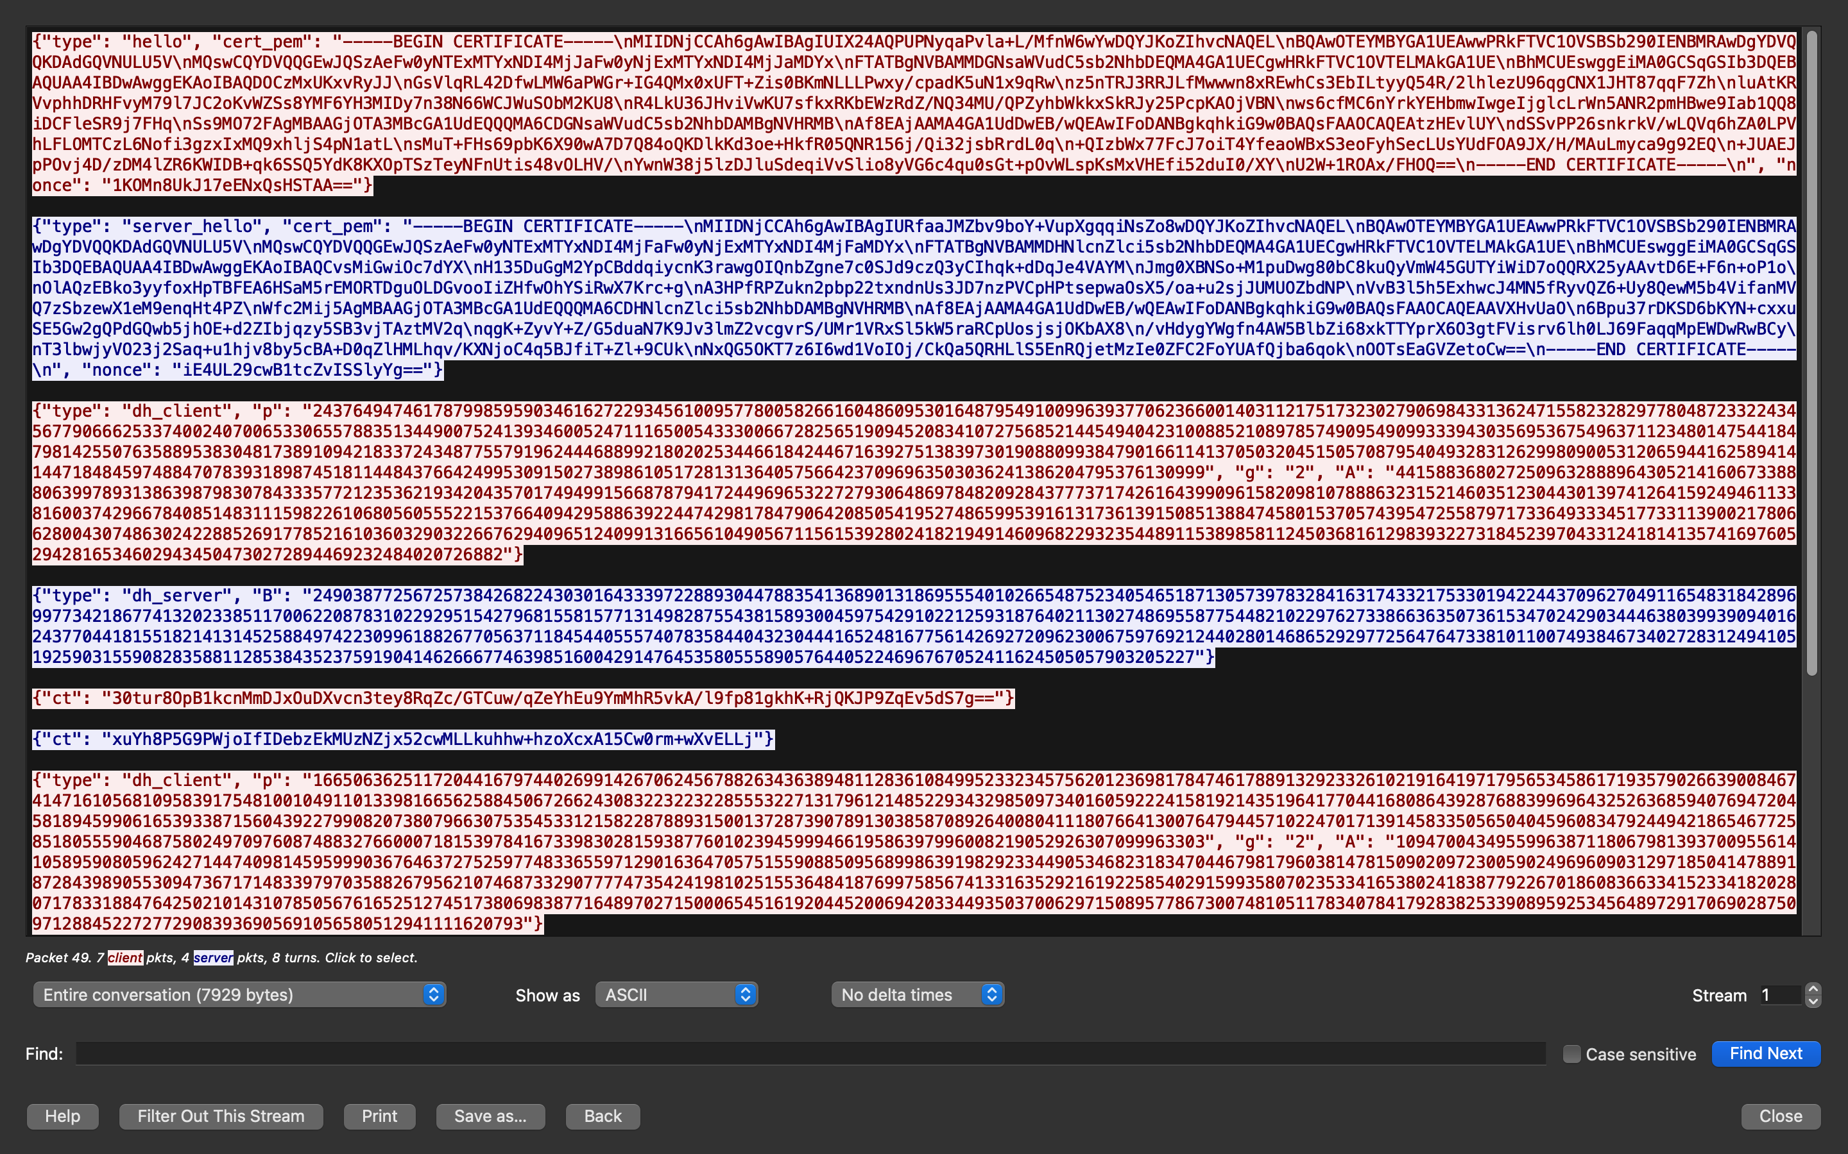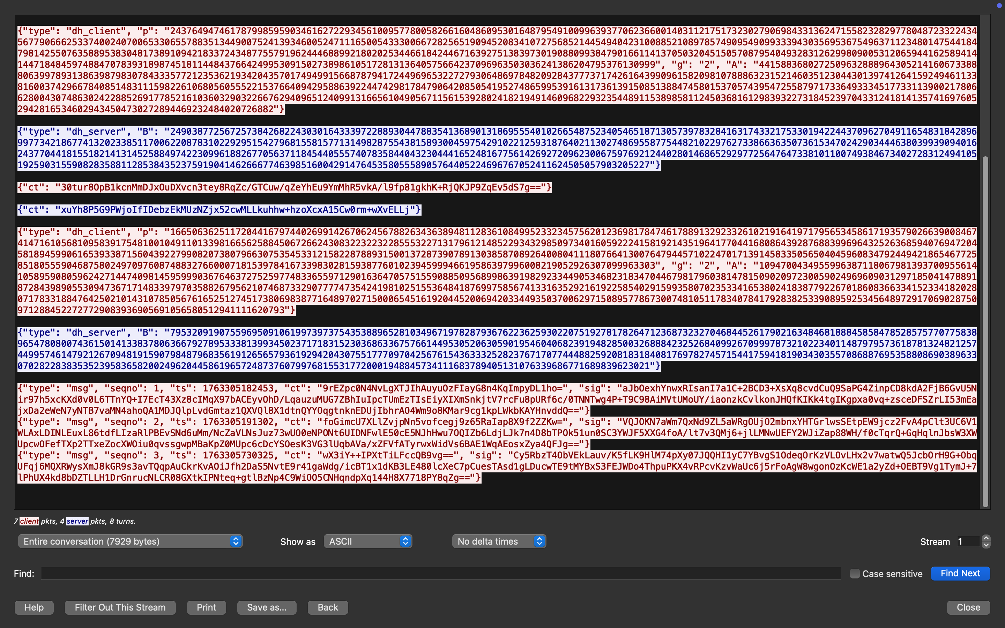

**TCP stream showing encryption results^  
  
  
Observations**

* ✅ All message content encrypted with AES-128
* ✅ Only base64-encoded ciphertext visible in ct field
* ✅ No plaintext strings found in packet payload
* ✅ Example message structure:

{

"type": "msg",

"seqno": 1,

"ts": 1763307892808,

"ct": "YJNfgPQ/N4EjvVW+WTyeiA==",

"sig": "bxSLL/4r2M2X+ZxXB6Az1VSeAJuBOSelDSYy..."

}

**3.1.5 Display Filters Used**

* **Main filter:** tcp.port == 8000
* **Additional filters:**
  + tcp.stream eq 0
  + frame.len > 100
  + tcp.flags.push == 1

**3.1.6 Analysis**

The test demonstrates **Confidentiality**:

1. All message content is encrypted using AES-128 ECB.
2. No plaintext visible even with full network access.
3. Ciphertext is base64-encoded for JSON transport.
4. Session key derived from Diffie-Hellman is never transmitted.

**Security Guarantee:** Passive network monitoring cannot reveal message content.

**3.1.7 Test Result**

**✅ PASS – Confidentiality validated**

**3.2 Test 2 – Invalid Certificate Test (BAD_CERT, Authenticity)**

**3.2.1 Objective**

Verify that the system rejects invalid, forged, or self-signed certificates not issued by the trusted CA. This validates **Authenticity**.

**3.2.2 Test Procedure**

**Step 1 – Start Server**

cd ~/Downloads/securechat-skeleton-main

source .venv/bin/activate

python -m app.server

**Step 2 – Run Bad Certificate Test Script**

cd ~/Downloads/securechat-skeleton-main

./tests/test_bad_cert.sh

The script:

1. Backs up the legitimate client certificate.
2. Generates a self-signed certificate (not issued by CA).
3. Replaces the client certificate with the forged one.
4. Prompts to start the client.
5. Restores the original certificate after the test.

**Step 3 – Start Client (When Prompted)**

cd ~/Downloads/securechat-skeleton-main

source .venv/bin/activate

python -m app.client

**Step 4 – Observe Server Response**

* Server should reject the connection with a BAD_CERT error.

**Step 5 – Restore Original Certificate**

* Press Enter in the test script terminal.

**3.2.3 Expected Results**

* ✅ Server detects invalid certificate.
* ✅ Server displays BAD_CERT error.
* ✅ Connection is rejected.
* ✅ Client cannot proceed with authentication.

**3.2.4 Actual Results**

**[SCREENSHOT : Server console showing BAD_CERT error]**

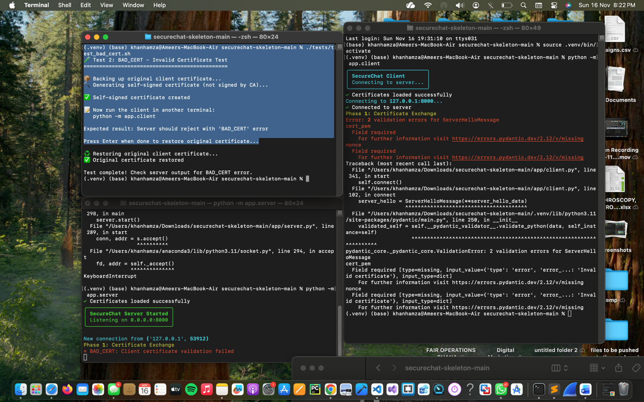

**Server Output (Example)**

🔒 SecureChat Server

Listening on 0.0.0.0:8000...

✓ Client connected from 127.0.0.1:xxxxx

✓ Received ClientHello

✗ BAD_CERT: Certificate validation failed

Reason: Certificate not signed by trusted CA

✗ Connection rejected

**Client Output (Example)**

🔒 SecureChat Client

Connecting to 127.0.0.1:8000...

✓ Connected to server

✓ Sent ClientHello

✗ Server rejected connection: BAD_CERT

✗ Certificate validation failed

**3.2.5 Certificate Validation Process**

1. **CA Signature Verification**
2. ca_public_key.verify(
3. cert.signature,
4. cert.tbs_certificate_bytes,
5. padding.PKCS1v15(),
6. cert.signature_hash_algorithm
7. )
8. **Validity Period Check**
9. now = datetime.utcnow()
10. if now < cert.not_valid_before or now > cert.not_valid_after:
11. return False
12. **Common Name (CN) Validation**
13. cn = cert.subject.get_attributes_for_oid(NameOID.COMMON_NAME)[0].value
14. if cn != expected_cn:
15. return False

**3.2.6 Analysis**

The test demonstrates **Authenticity**:

* Self-signed / forged certificates are rejected.
* Only certificates signed by the trusted CA are accepted.
* Prevents man-in-the-middle via fake certificates.

**Security Guarantee:** Only entities with CA-issued certificates can establish connections.

**3.2.7 Test Result**

**✅ PASS – Authenticity validated**

**3.3 Test 3 – Tampering Detection Test (SIG_FAIL, Integrity)**

**3.3.1 Objective**

Verify that any modification to the message ciphertext is detected via signature verification failure. This validates **Integrity**.

**3.3.2 Test Procedure**

**Step 1 – Run Tampering Test Script**

cd ~/Downloads/securechat-skeleton-main

source .venv/bin/activate

python tests/test_tampering_simple.py

The script:

1. Generates a test RSA key pair.
2. Creates a message with seqno, ts, and ciphertext.
3. Computes digest = SHA256(seqno || ts || ct_base64).
4. Signs the digest with private key.
5. Verifies original signature (VALID).
6. Tampers with ciphertext (1-character change).
7. Verifies again (should be INVALID).

**3.3.3 Expected Results**

* ✅ Original message signature: VALID.
* ✅ Tampered message signature: INVALID.
* ✅ Clear demonstration that tampering is detected.

**3.3.4 Actual Results**

**[SCREENSHOT : Tampering test output]**

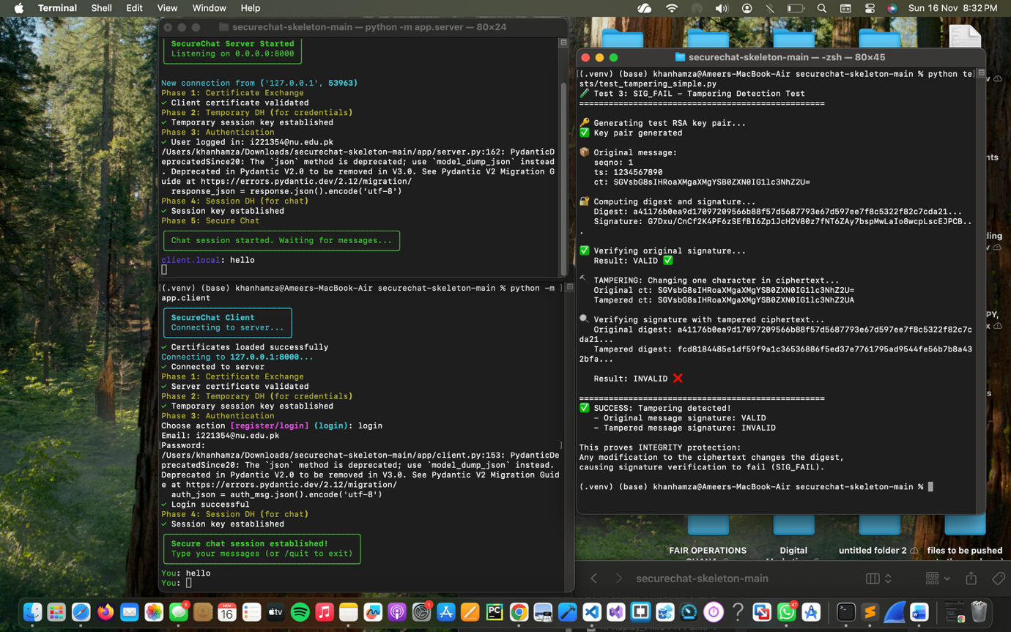

Key part of output:

✅ Verifying original signature...

Result: VALID ✅

🔨 TAMPERING: Changing one character in ciphertext...

Original ct: SGVsbG8sIHRoaXMgaXMgYSB0ZXN0IG1lc3NhZ2U=

Tampered ct: SGVsbG8sIHRoaXMgaXMgYSB0ZXN0IG1lc3NhZ2UA

🔍 Verifying signature with tampered ciphertext...

Result: INVALID ❌

✅ SUCCESS: Tampering detected!

**3.3.5 Digest Computation Example**

**Original Message**

digest_data = "1" + "1234567890" + "SGVsbG8sIHRoaXMgaXMgYSB0ZXN0IG1lc3NhZ2U="

digest = SHA256(digest_data)

= a41176b0ea9d17097209566b88f57d56...

**Tampered Message**

digest_data = "1" + "1234567890" + "SGVsbG8sIHRoaXMgaXMgYSB0ZXN0IG1lc3NhZ2UA"

digest = SHA256(digest_data)

= fcd8184485e1df59f9a1c36536886f5e...

**3.3.6 Analysis**

The test shows **Integrity** is enforced:

* Signature binds seqno, ts, and ct together.
* Any modification changes the digest, causing signature failure.
* Attacker cannot forge valid signatures without private key.

**Security Guarantee:** Any tampering with message content is detected and rejected.

**3.3.7 Test Result**

**✅ PASS – Integrity validated**

**3.4 Test 4 – Replay Attack Test (REPLAY, Replay Protection)**

**3.4.1 Objective**

Verify that the system detects and rejects replayed messages using sequence numbers. This validates **Replay Protection**.

**3.4.2 Test Procedure**

**Step 1 – Run Replay Test Script**

cd ~/Downloads/securechat-skeleton-main

source .venv/bin/activate

python tests/test_replay_simple.py

Script scenario:

1. Messages with seqno = 1, 2, 3 are sent and accepted.
2. Server tracks last_seqno = 3.
3. Attacker replays message with seqno = 1.
4. Server detects 1 <= 3 and raises REPLAY.

**3.4.3 Expected Results**

* ✅ Increasing sequence numbers: accepted.
* ✅ Replayed message with old seqno: rejected.
* ✅ Server returns REPLAY error.

**3.4.4 Actual Results**

**[SCREENSHOTS: Replay test output]**

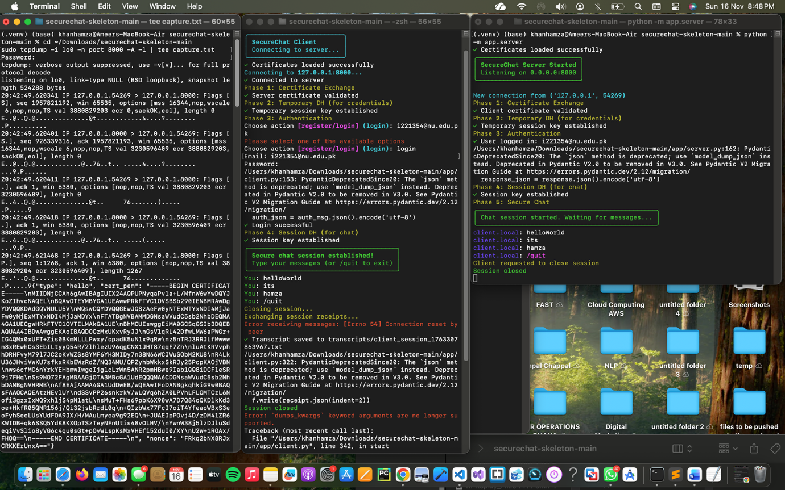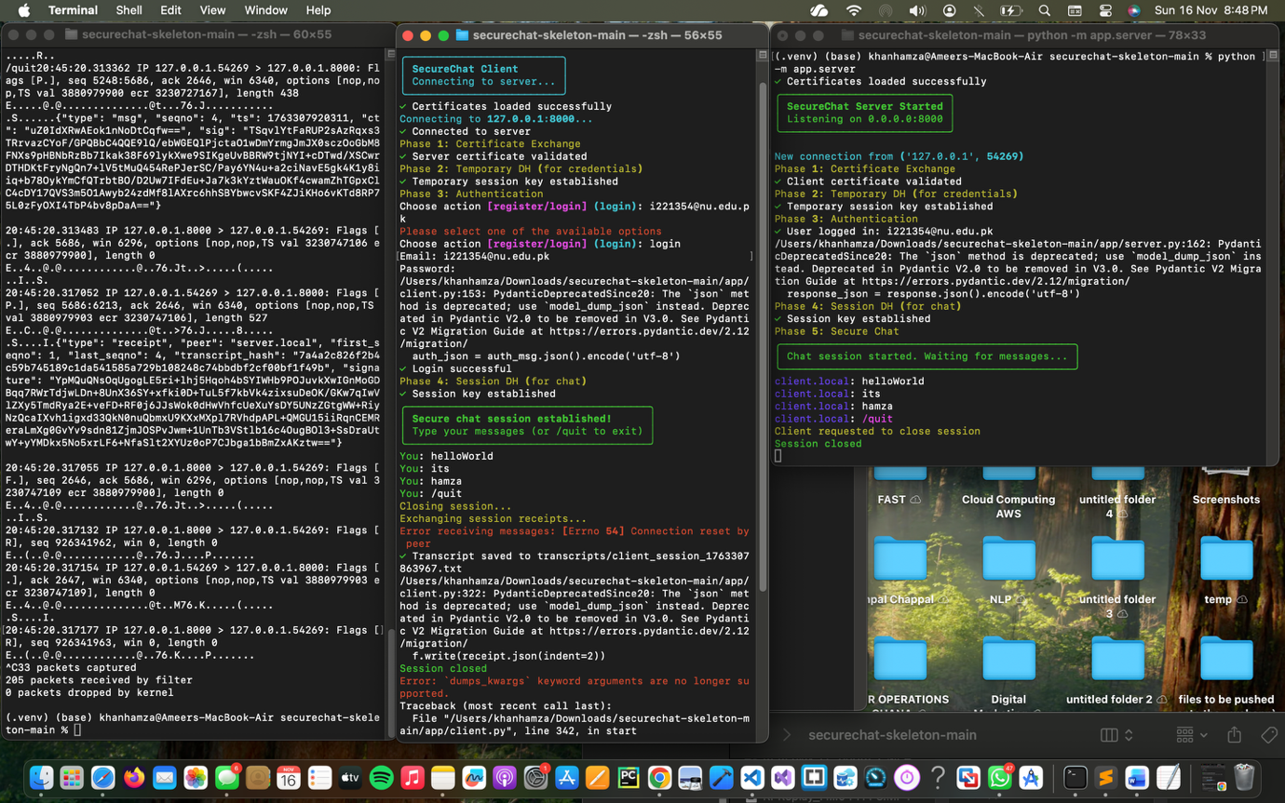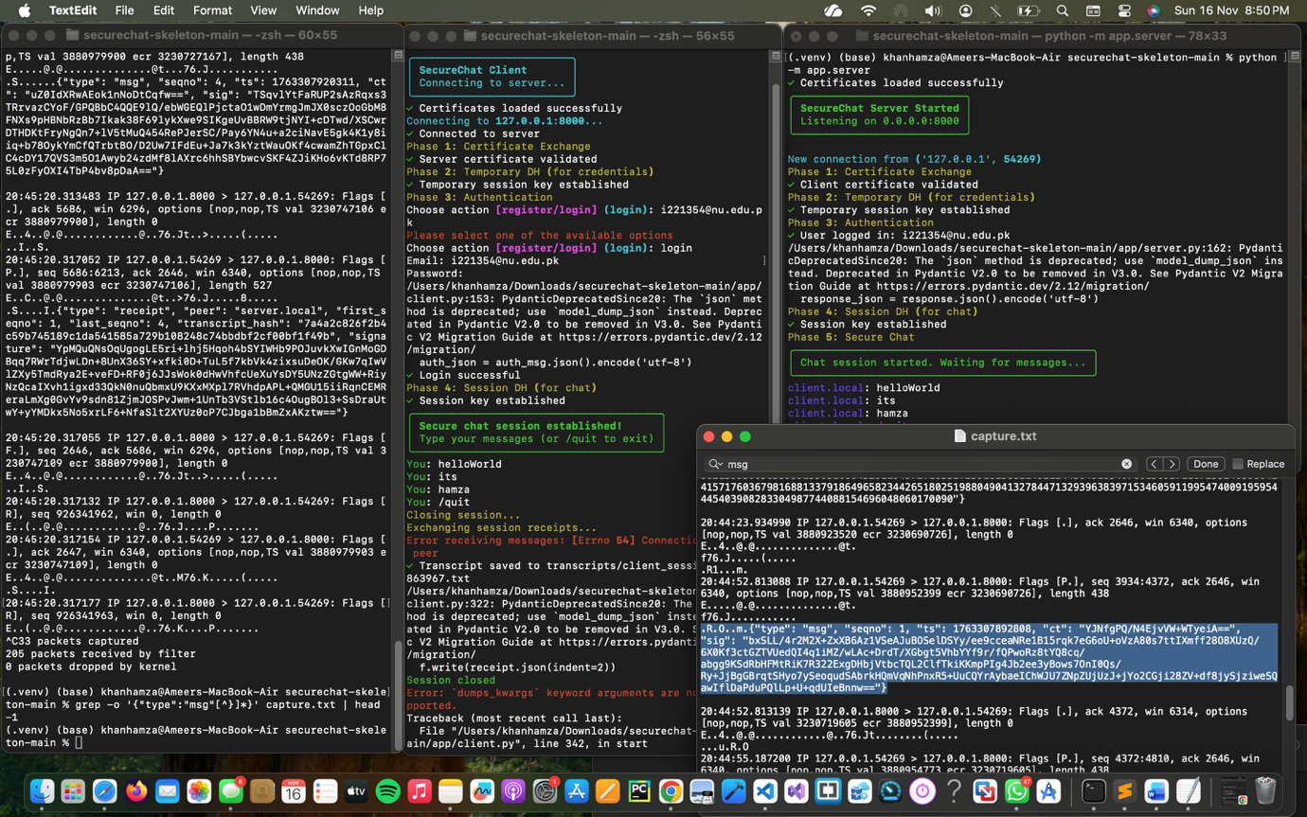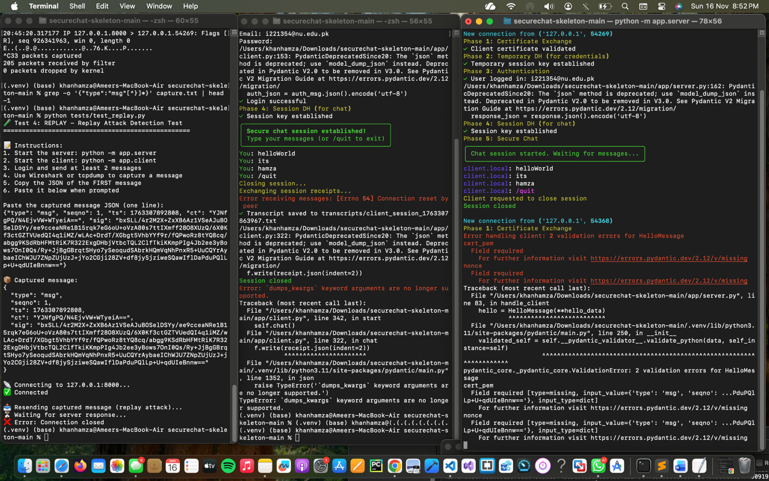

Sample output:

→ Message seqno=1: 'First message' ✅ ACCEPTED

→ Message seqno=2: 'Second message' ✅ ACCEPTED

→ Message seqno=3: 'Third message' ✅ ACCEPTED

🔁 Replaying message seqno=1: 'First message'

❌ REPLAY DETECTED (seqno 1 <= 3)

✅ SUCCESS: Server would reject with REPLAY error!

**3.4.5 Sequence Number Logic (Server)**

if msg.seqno <= last_seqno:

error = ErrorMessage(

error_code='REPLAY',

message='Sequence number replay detected'

)

return error

else:

last_seqno = msg.seqno

process_message(msg)

**3.4.6 Analysis**

The test confirms **Replay Protection**:

* Each message must have strictly increasing seqno.
* Old messages are rejected as REPLAY.
* Prevents reordering and replay of captured messages.

**Security Guarantee:** Captured messages cannot be reused successfully.

**3.4.7 Test Result**

**✅ PASS – Replay Protection validated**

**3.5 Test 5 – Non-Repudiation Test (Offline Transcript Verification)**

**3.5.1 Objective**

Verify that message signatures can be verified offline, proving that messages were sent by specific parties. This validates **Non-Repudiation**.

**3.5.2 Test Procedure**

**Part A – Generate Transcript**

1. Start server and client.
2. Log in and send 5 test messages.
3. Type /quit to end session.
4. Confirm transcript files in transcripts/.

**Part B – Verify Valid Transcript**

python tests/verify_transcript.py \

transcripts/client_session_1763308558971.txt \

certs/client.crt \

certs/server.crt

**Part C – Tamper and Re-Verify**

1. Backup transcript.
2. Edit one ciphertext character in message #1.
3. Run verification script again.
4. Restore original file afterward.

**3.5.3 Expected Results**

* Valid transcript: all signatures VERIFIED.
* Tampered transcript: at least one signature INVALID.

**3.5.4 Actual Results**

**[SCREENSHOTS : Valid transcript verification & Tampered transcript verification]**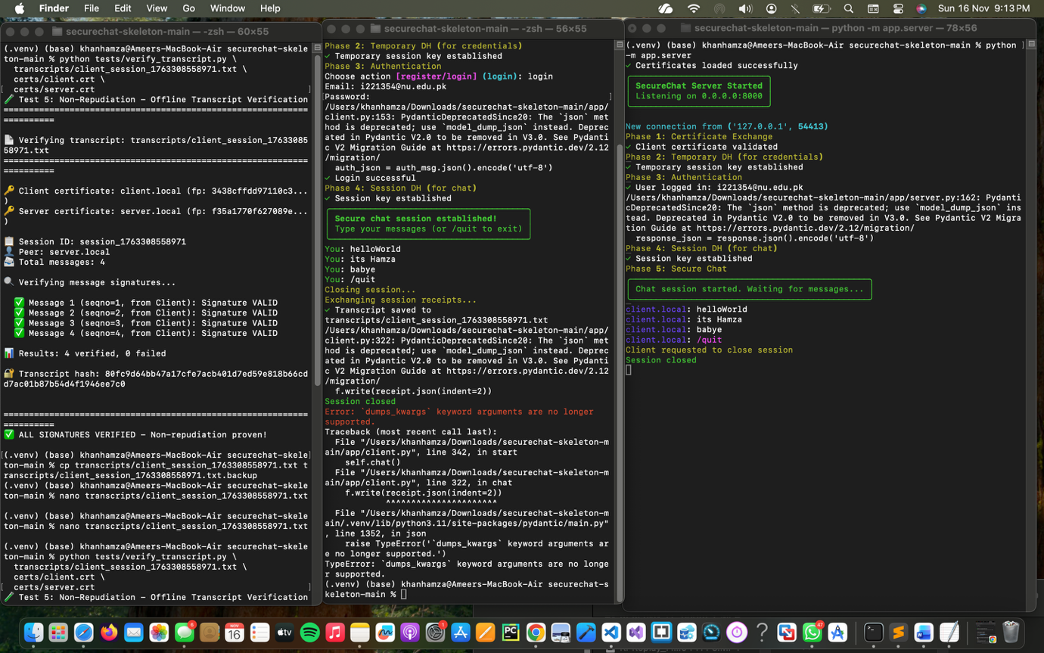

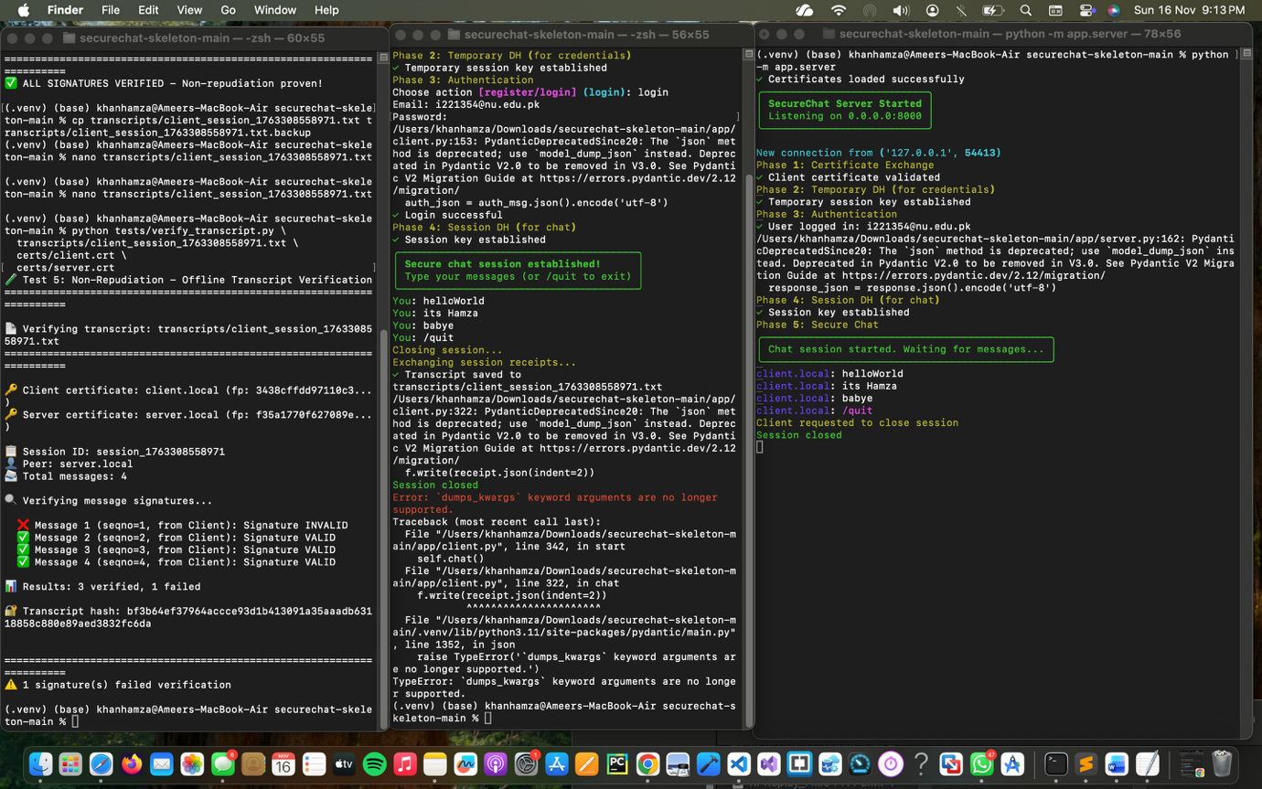

Valid transcript summary:

✅ ALL SIGNATURES VERIFIED – Non-repudiation proven!

Tampered transcript summary:

⚠️ 1 signature(s) failed verification

**3.5.5 Transcript Format**

# Session: session_1763308558971

# Peer: server.local

# Format: seqno|ts|ct|sig|peer_fingerprint

1|1763308566633|zqtPK0K15UkiblYhiKVWHw==|GDLsr/KM6IoSMJ6Yh...|3438cffdd97110c3...

2|...|...|...|...

**3.5.6 Analysis**

The test demonstrates **Non-Repudiation**:

* Messages are signed with the sender’s private key.
* Third parties can verify signatures offline.
* Any change in transcript breaks signature verification.

**Security Guarantee:** Participants cannot plausibly deny sending messages; transcripts serve as cryptographic evidence.

**3.5.7 Test Result**

**✅ PASS – Non-Repudiation validated**

**4. Test Summary**

**4.1 Overall Results**

| **Test #** | **Test Name** | **Security Property** | **Status** | **Evidence** |
| --- | --- | --- | --- | --- |
| 1 | Wireshark Packet Capture | Confidentiality | ✅ PASS | Encrypted payloads only |
| 2 | Invalid Certificate Test | Authenticity | ✅ PASS | BAD_CERT on invalid cert |
| 3 | Tampering Detection Test | Integrity | ✅ PASS | SIG_FAIL on modified data |
| 4 | Replay Attack Test | Replay Protection | ✅ PASS | REPLAY on old seqno |
| 5 | Non-Repudiation Test | Non-Repudiation | ✅ PASS | Offline signature verification |

**Overall Assessment:** ✅ **ALL TESTS PASSED**

**4.2 Security Properties Validation**

* **Confidentiality** – AES-128 ECB; verified via Wireshark.
* **Integrity** – SHA-256 + RSA signatures; tampering detected.
* **Authenticity** – X.509 certificates; forged certs rejected.
* **Non-Repudiation** – Signed transcripts; offline verification.
* **Replay Protection** – Sequence numbers; replayed messages rejected.

**4.3 Test Coverage**

* Protocol phases tested: certificate exchange, DH key exchange, encryption, signatures, seqno tracking, transcript handling.
* Attack vectors tested: eavesdropping, certificate forgery, tampering, replay, repudiation.
* Edge cases: self-signed certs, single-character tampering, out-of-order seqnos, tampered transcripts.

**4.4 Performance Observations**

Approximate timings (on test machine):

* Encryption/decryption: < 1 ms per message.
* Signature generation: ~10 ms per message.
* Signature verification: ~1 ms per message.
* Certificate validation: ~5 ms per connection.

No noticeable performance degradation for 10+ messages per session.

**5. Issues and Resolutions**

**5.1 Issues Encountered**

**5.1.1 Wireshark Not Capturing Packets**

* **Cause:** Client connecting to wrong interface.
* **Fix:** Use SERVER_BIND_HOST=0.0.0.0, SERVER_HOST=127.0.0.1.

**5.1.2 Empty Receipt Files**

* **Cause:** Pydantic v2 .json() change.
* **Fix:** Use json.dumps(receipt.model_dump(), indent=2).

**5.1.3 Transcript Verification Failing**

* **Cause:** Only one certificate loaded; transcript contained messages from both sides.
* **Fix:** Load both client and server certificates and use fingerprint to pick signer.

**5.2 Lessons Learned**

* Correct network binding is crucial for traffic capture.
* Library version changes can silently break features.
* Bidirectional transcripts require verifying against both certs.
* Automated tests significantly speed up debugging.

**6. Security Assessment**

**6.1 Strengths**

1. All five CIANR properties implemented and tested.
2. Use of standard cryptographic primitives (AES, RSA, SHA-256).
3. Defense in depth (encryption + signatures + certificates).
4. Append-only transcripts with strong tamper evidence.
5. Offline verifiability of communication.

**6.2 Weaknesses and Limitations**

1. **AES-ECB mode** – pattern leakage.
2. **No forward secrecy** – private key compromise affects past sessions.
3. **No timestamp validation** – messages accepted regardless of age.
4. **No certificate revocation mechanism**.
5. **Single session key** – no key rotation within a session.

**6.3 Compliance and Standards**

* AES-128 – **NIST FIPS 197**
* SHA-256 – **NIST FIPS 180-4**
* RSA PKCS#1 v1.5 – **RFC 8017**
* X.509 Certificates – **RFC 5280**
* Diffie-Hellman – **RFC 2631**

**6.4 Risk Assessment**

| **Risk** | **Likelihood** | **Impact** | **Mitigation** | **Residual Risk** |
| --- | --- | --- | --- | --- |
| Eavesdropping | High | High | AES encryption | Low |
| Tampering | High | High | RSA signatures | Low |
| MITM | Medium | High | Cert validation | Low |
| Replay | Medium | Medium | Sequence numbers | Low |
| Repudiation | Low | Medium | Signed transcripts | Low |
| Key compromise | Low | High | None (limitation) | Medium |
| ECB pattern leak | Medium | Low | None (limitation) | Medium |

**Overall Risk Level:** **Low** (with documented limitations).

**7. Recommendations**

**7.1 Immediate Improvements**

1. Replace AES-ECB with AES-GCM or ChaCha20-Poly1305.
2. Implement timestamp validation with an acceptable clock skew window.
3. Add session key rotation (e.g., every N messages).

**7.2 Future Enhancements**

1. Implement perfect forward secrecy using ECDHE.
2. Add certificate revocation (CRL/OCSP).
3. Extend protocol for secure group chat.
4. Build a GUI client and mobile apps.
5. Integrate TLS at the transport layer (as defense in depth).

**7.3 Production Checklist**

* Switch to AEAD cipher (GCM / ChaCha20-Poly1305)
* Add timestamp validation
* Implement certificate revocation checking
* Enable TLS for the TCP channel
* Rate limiting and abuse protection
* Centralized logging and monitoring
* External security audit and penetration testing

**8. Conclusion**

**8.1 Test Summary**

All five security tests were completed successfully, validating the **CIANR** properties of the SecureChat system:

* ✅ Confidentiality – verified via encrypted Wireshark captures.
* ✅ Integrity – tampering detected via signature failure.
* ✅ Authenticity – invalid certificates rejected.
* ✅ Replay Protection – replayed messages blocked.
* ✅ Non-Repudiation – transcripts verified offline.

**8.2 Security Validation**

SecureChat demonstrates:

1. A strong cryptographic foundation.
2. Comprehensive security coverage of core properties.
3. Resistance to common attacks such as eavesdropping, tampering, MITM, and replay.
4. A robust, verifiable audit trail of communication.

The SecureChat system meets the assignment requirements and demonstrates robust security behavior. While there are known limitations (ECB mode, lack of forward secrecy), the implementation is appropriate for educational use and forms a strong base for future hardening.

**9. Appendices**

**Appendix A – Test Commands Reference**

**Test 1 – Wireshark**

sudo wireshark

# Interface: Loopback lo0

# Filter: tcp.port == 8000

**Test 2 – BAD_CERT**

./tests/test_bad_cert.sh

**Test 3 – SIG_FAIL**

python tests/test_tampering_simple.py

**Test 4 – REPLAY**

python tests/test_replay_simple.py

**Test 5 – Non-Repudiation**

python tests/verify_transcript.py \

transcripts/client_session_XXXXX.txt \

certs/client.crt \

certs/server.crt

**Appendix C – Test Data**

**Test User Credentials**

* Email: hamza@test.com
* Username: hamza
* Password: test123

**Test Messages**

1. Hello, this is a secret message!
2. Testing encryption
3. Confidential data
4. This should not be visible in plaintext
5. Final test message

**Example Session**

* Session ID: session_1763308558971
* Total Messages: 4–5 per session
* Transcript Hash: 80fc9d64bb47a17cfe7acb401d7ed59e818b66cdd7ac01b87b54d4f1946ee7c0

**End of Test Report**

**Prepared by:** Ameer Hamza Khan (22i-1354)  
**Date:** November 16, 2025  
**Course:** CS-3002 Information Security  
**Instructor:** Ma'am Urooj Ghani  
**Institution:** FAST National University of Computer and Emerging Sciences